# **Steps to install UFT**

Link: https://www.microfocus.com/en-us/products/unified-functional-automated-testing/free-trial

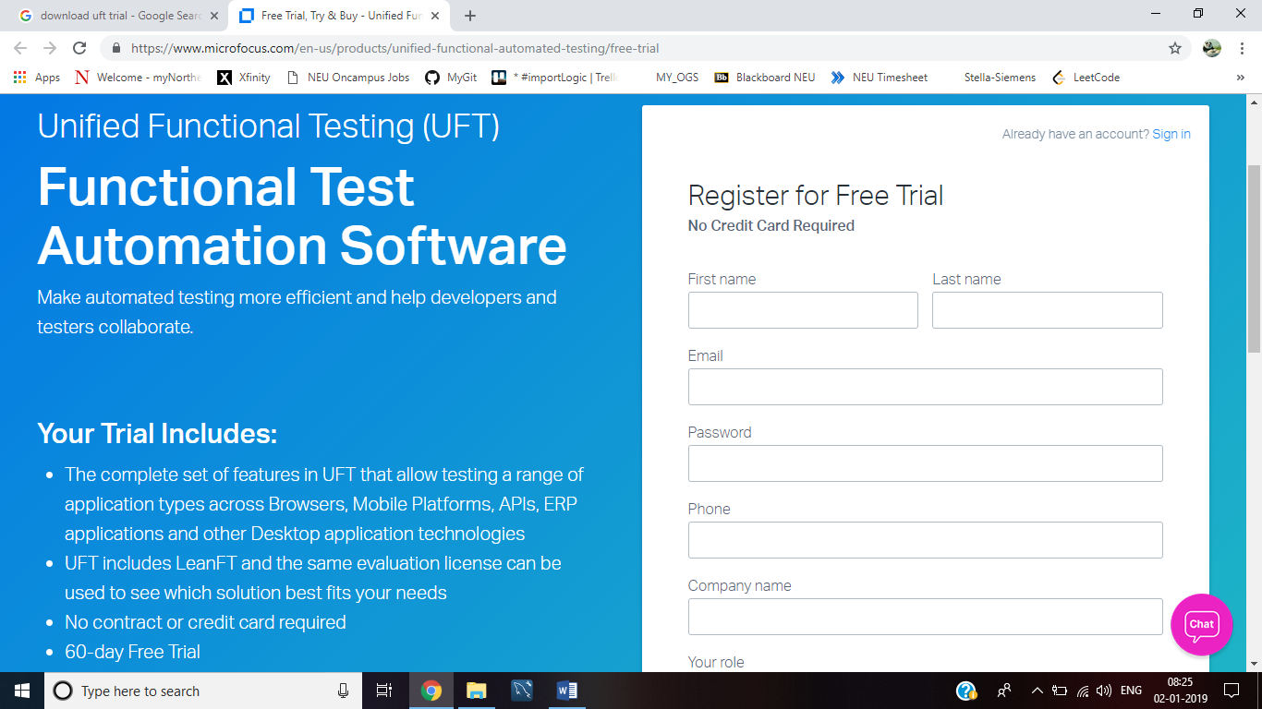

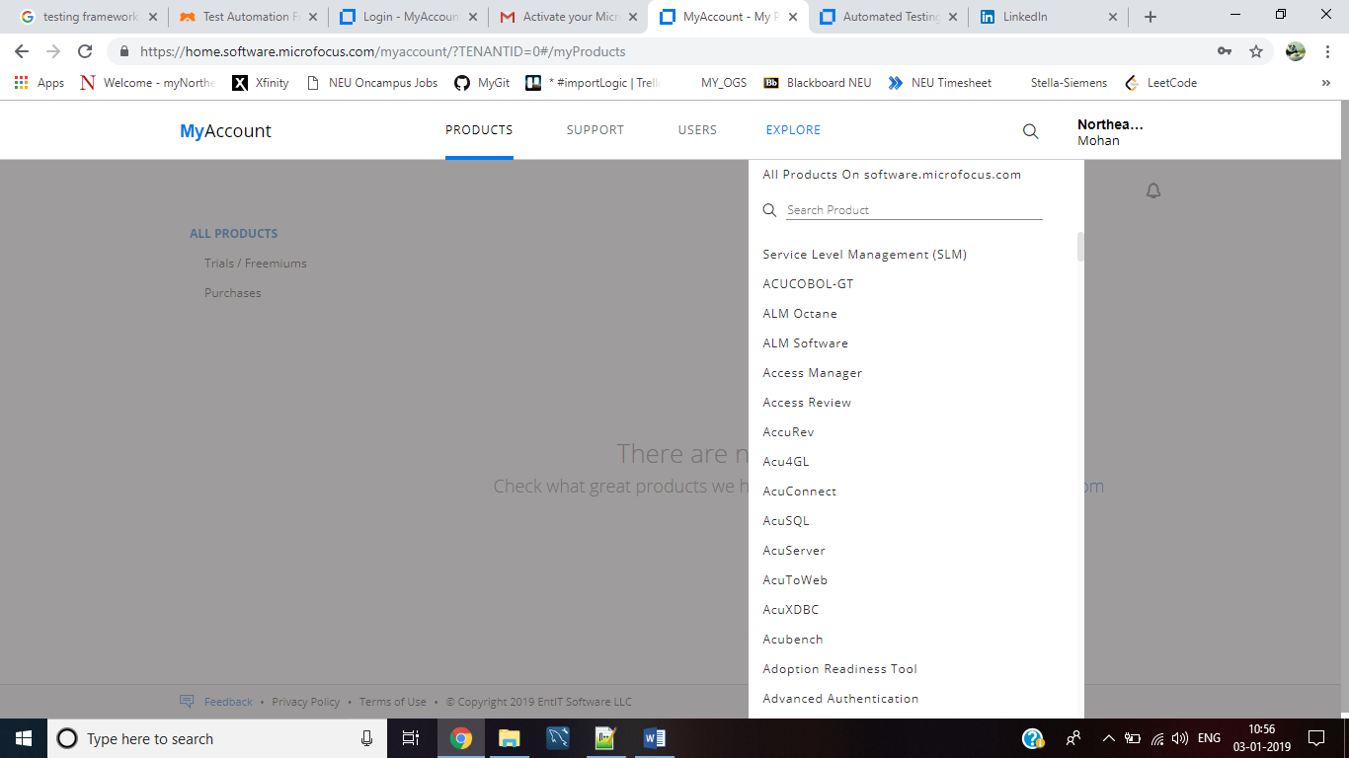

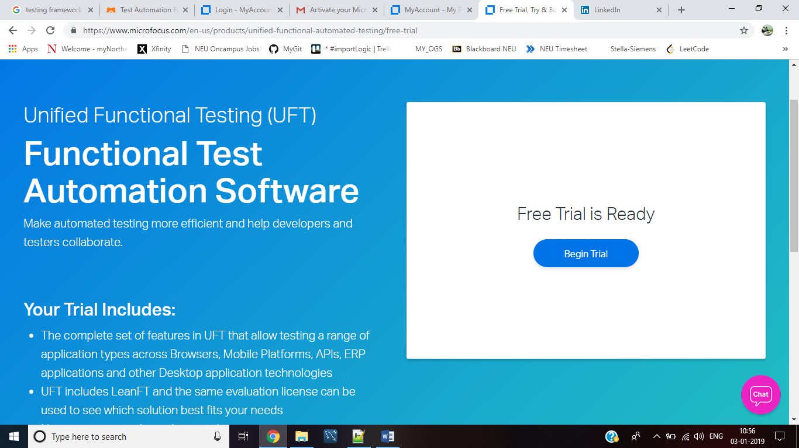

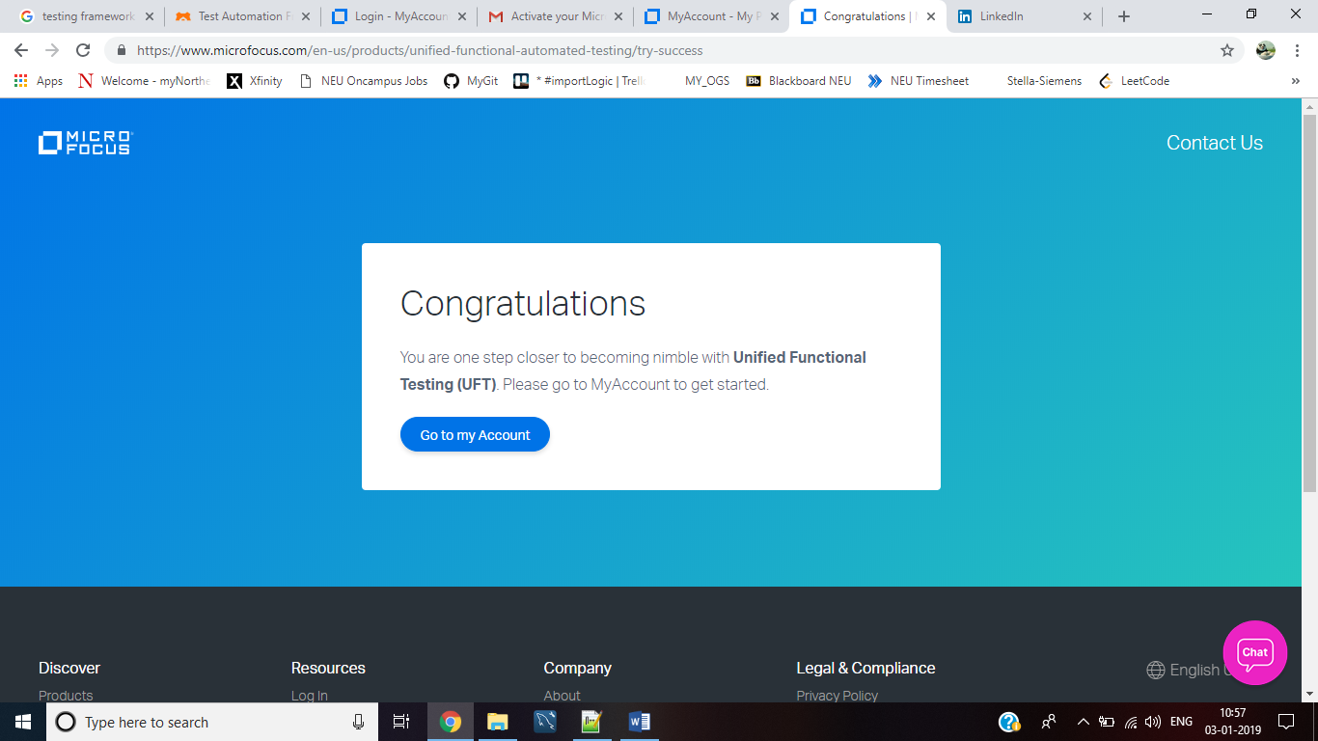

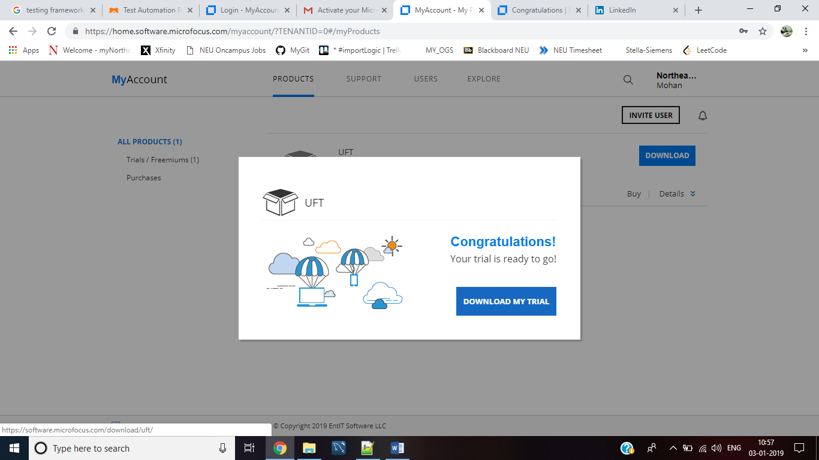

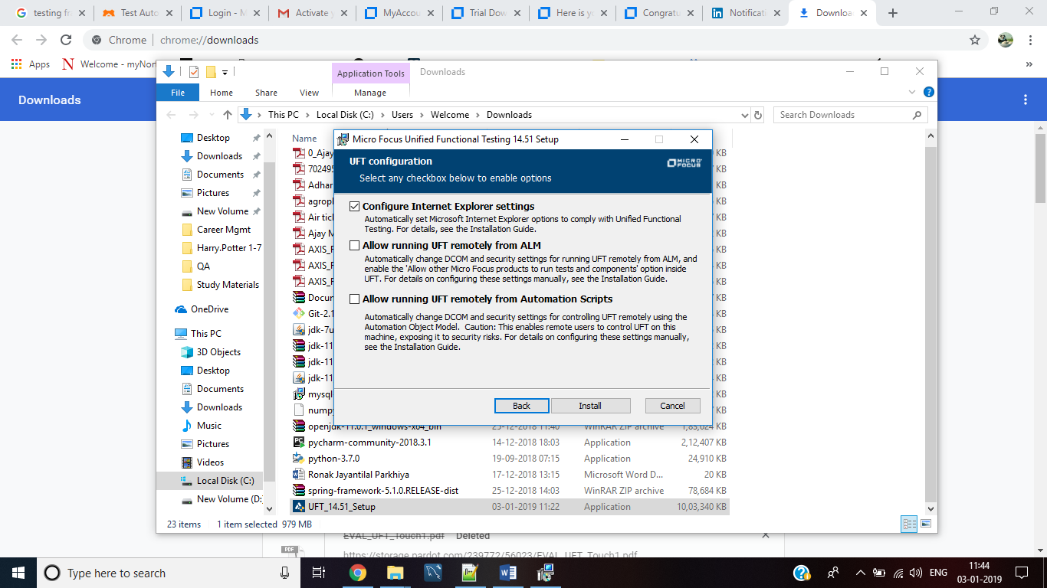

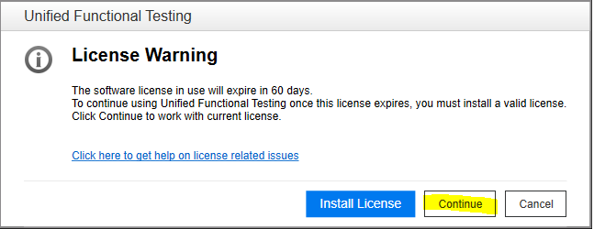

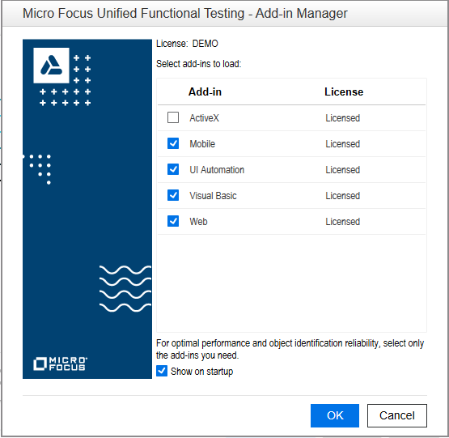

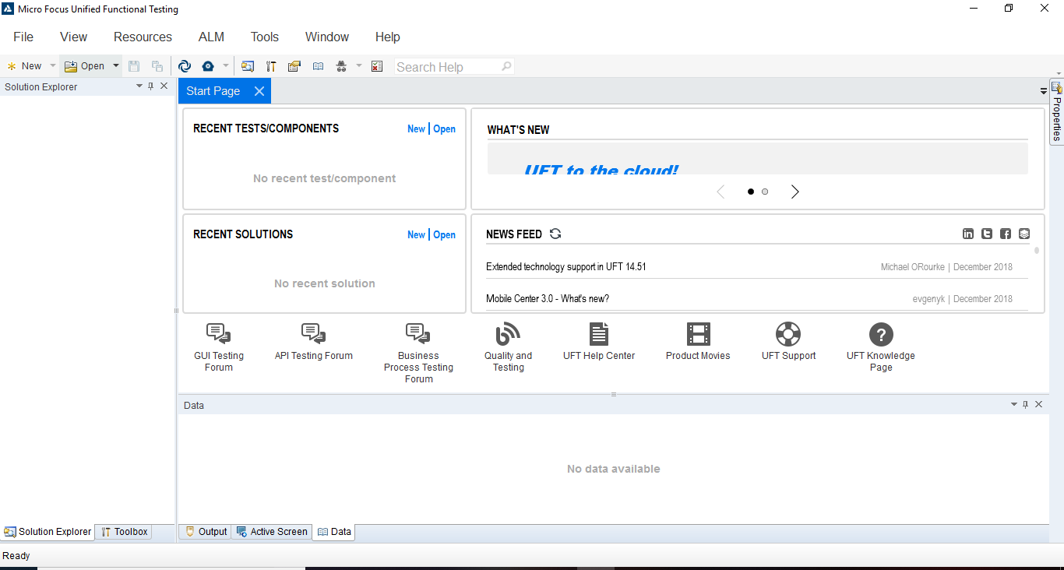

# Guide to install UFT Connection Agent on MAC

The UFT Connection Agent is a service installed on your Apple Mac computer, which enables UFT to communicate with the Safari browser using the WebSockets protocol. This enables UFT to run tests on Web applications running in Safari on the Mac and to spy on objects in these applications.

Perform the following steps to install the UFT Connection Agent:

Prerequisites:

* You must have administrator permissions to install the UFT Connection Agent.
* All Mac users that use the UFT Connection Agent must have the agent installed in their Mac user account.

To run the installation:

1. Copy the installer image file (**UFTConnectionAgent.dmg**) from the **<UFT installation folder>/Installations/Safari** folder to the Mac.
2. Open the **UFTConnectionAgent.dmg** image file.
3. Double-click **UFT Connection Agent.pkg** to start the installation wizard. If you are prompted to install the extension from the Safari Extensions Gallery, click **Cancel**.

If you are working with Safari 11 or earlier, this installs both the UFT Connection Agent and the Unified Functional Testing Agent Safari extension. On later versions of Safari, follow the steps below, to install the Safari extension.

1. If you are working with Safari 12:
   1. Unpack the **UFTConnectionAgent.dmg** image file and save the **SafariUFT.safariextension** file from the package to your Mac. (**UFTConnectionAgent.dmg: Micro Focus UFT Connection Agent Installation\UFT Connection Agent.pkg\Payload\SafariUFT.safariextz\SafariUFT\SafariUFT.safariextension**).
   2. In Safari, add the **SafariUFT.safariextension** file (**Develop-> Show Extension Builder->Add Extension**).
   3. Locate **Run the Functional Testing Agent** in the list of Safari extensions (**Safari->Preferences-> Extension**) and run it.

**Note:**You need to run the agent again any time you close and reopen Safari and want to use the testing agent again.

Links for MAC users

Run HP UFT on MAC using Safari

<https://testguild.com/uft-gui-mac-using-safari/>

Install agent

<https://admhelp.microfocus.com/uft/en/14.50-14.53/UFT_Help/Content/Addins_Guide/Remote_Connection_AgentOnMac_Task.htm#mt-item-0>

# VB scripting

Basically, all scripting languages are programming languages. The theoretical difference between the two is that scripting languages do not require the compilation step and are rather interpreted. For example, normally, a C program needs to be compiled before running whereas normally, a scripting language like JavaScript or PHP need not be compiled.

Generally, compiled programs run faster than interpreted programs because they are first converted native machine code. Also, compilers read and analyze the code only once, and report the errors collectively that the code might have, but the interpreter will read and analyze the code statements each time it meets them and halts at that very instance if there is some error.

**Applications of Scripting Languages :**

1. To automate certain tasks in a program

2. Extracting information from a data set

# **Basics of UFT**

Link: <https://www.youtube.com/watch?v=ZA40vb7tI28>

# **Module 1: Record and run**

**Pre-requisite:** Before using any browser make sure to enable Microfocus testing agent.

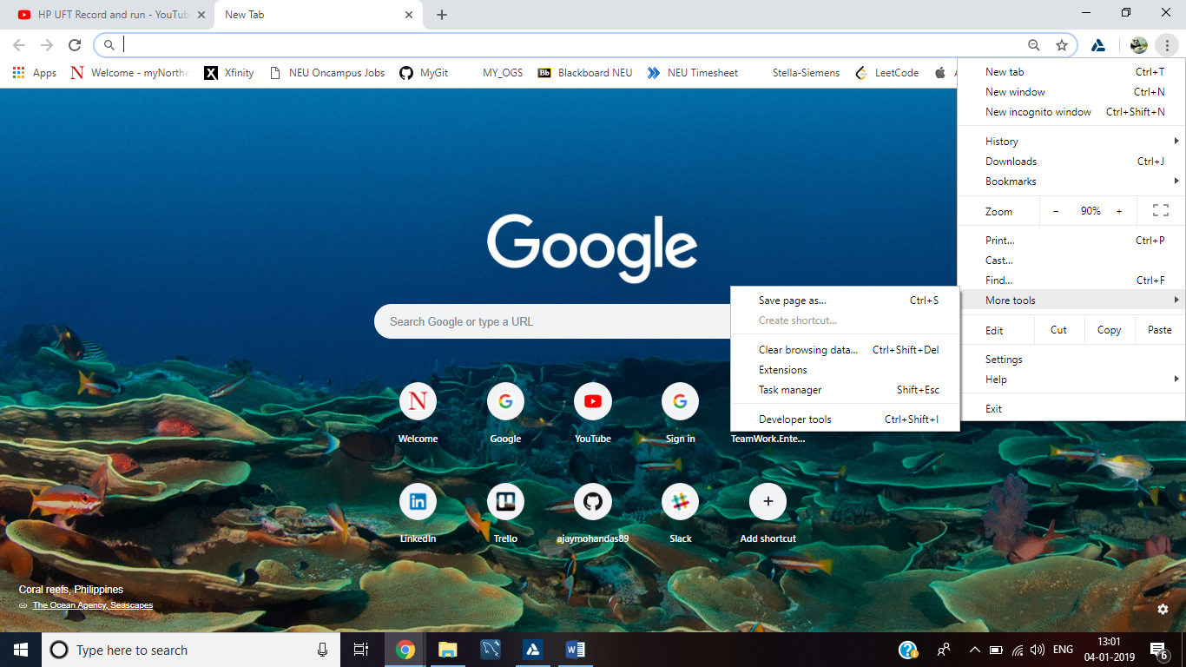

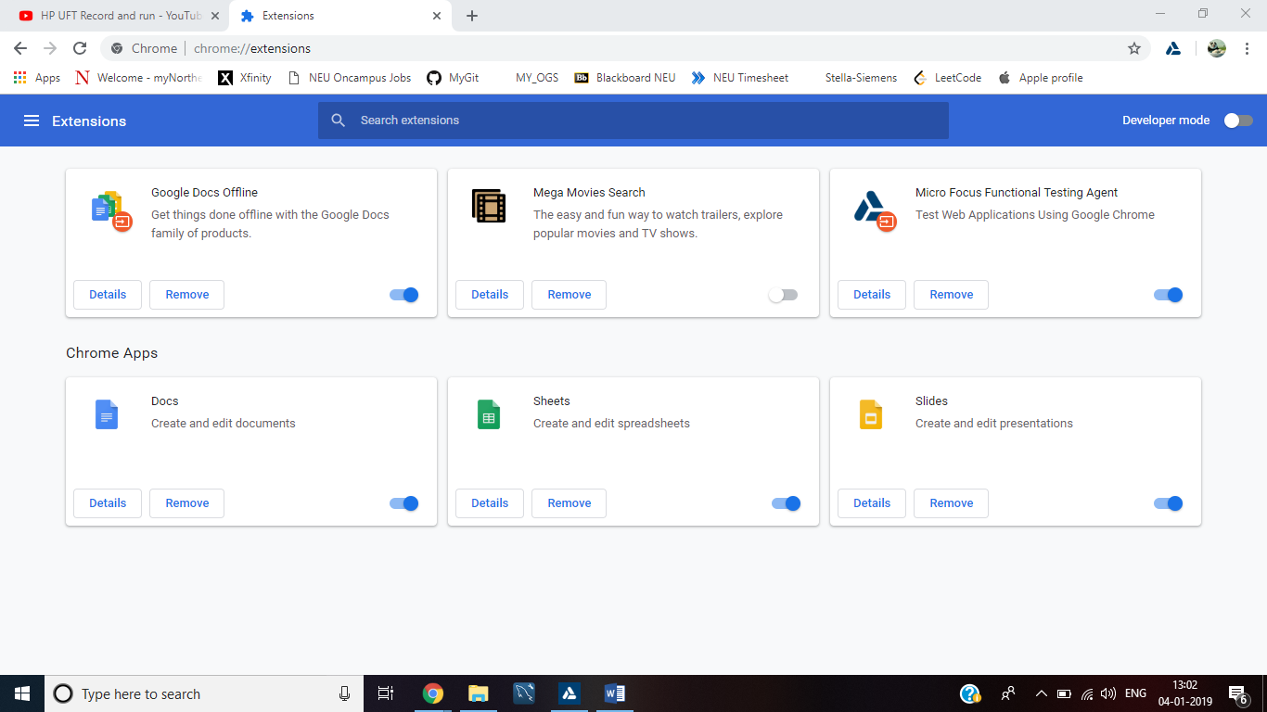

## Test 1: Using Web- Records and run on any open browser

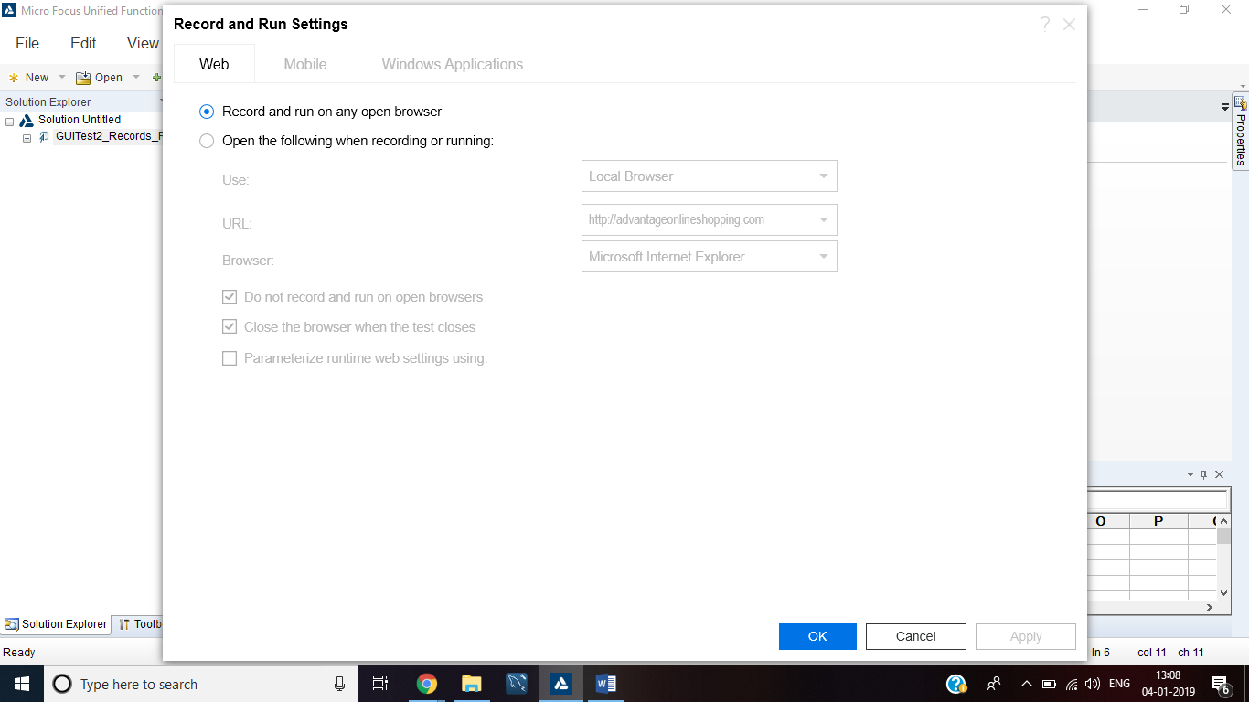

SystemUtil.Run "C:\Users\Welcome\AppData\Roaming\Microsoft\Internet Explorer\Quick Launch\User Pinned\TaskBar\Google Chrome.lnk","","",""

Browser("Google").Navigate "https://www.youtube.com/"

Browser("Google").Page("YouTube_2").WebEdit("Search").Set "hp uft"

Browser("Google").Page("YouTube_2").WebEdit("Search").Submit

Browser("Google").Page("YouTube_2").Link("HP UFT Record and run").Click

## Test2: Web- Open the following browser when recording or running

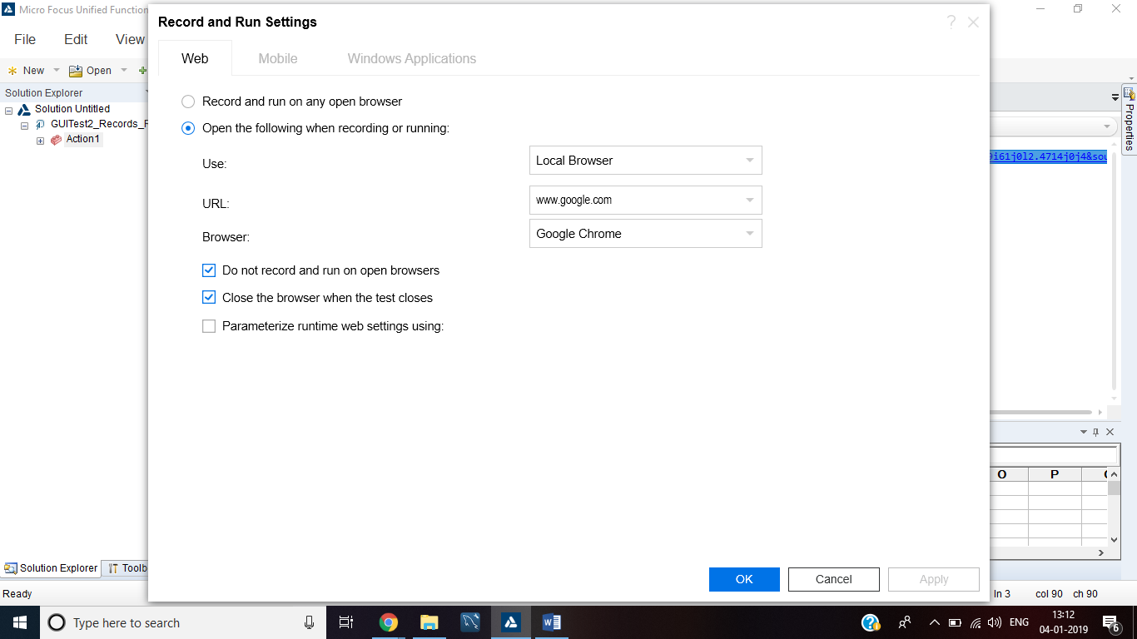

Browser("Google").Page("Google").Sync

Browser("Google").Navigate "https://www.google.com/search?q=hp+uft&rlz=1C1SQJL_enIN810IN810&oq=hp+uft&aqs=chrome..69i57j69i60l2j69i61j0l2.4714j0j4&sourceid=chrome&ie=UTF-8"

Browser("Google").Page("hp uft - Google Search").Link("Automated Testing, Unified").Click

## Test 3: Object spy

How UFT works?

UFT works as object, properties and values:

Board is object,

Its properties are height, width, color

Values of each property are 10, 10, white

UFT does not store the object in the memory but its references/description i.e the property-value in the memory and recognizes the object. The place where UFT stores these references are object repository.

Object Identification helps UFT to capture the properties of an object. It is present in Tools🡪Object Identification

If all properties are selected then size of the file also increases hampering the performance of the script.

Note: Make sure the window/application you want to spy should be open and use object spy.

Adding the whole page of website:

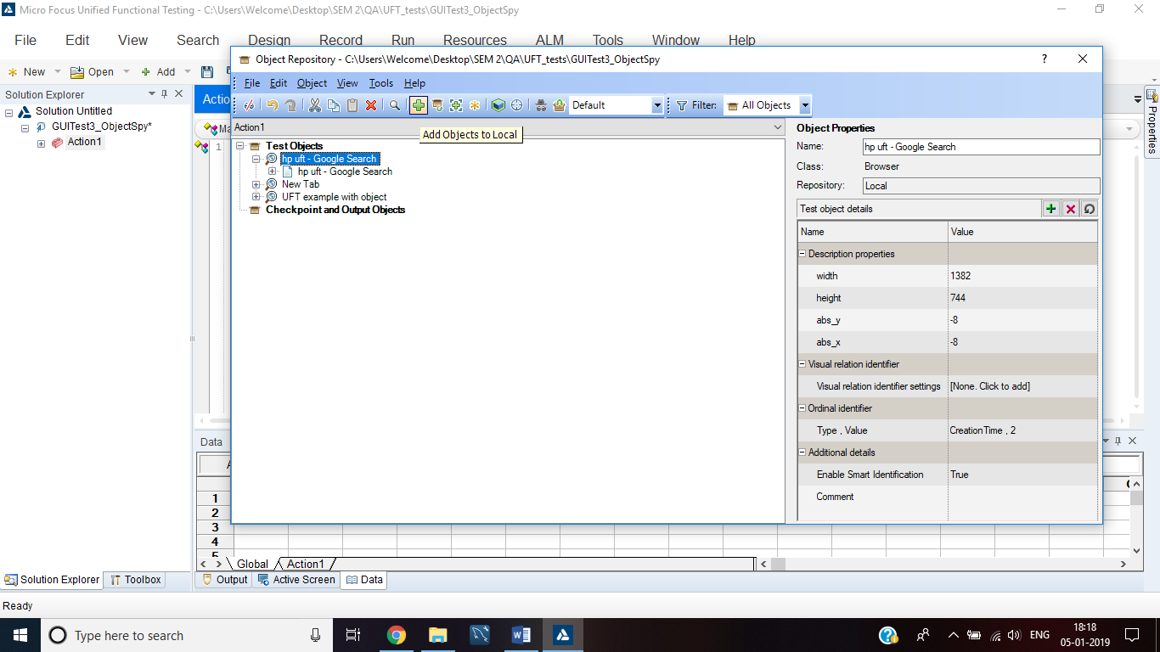

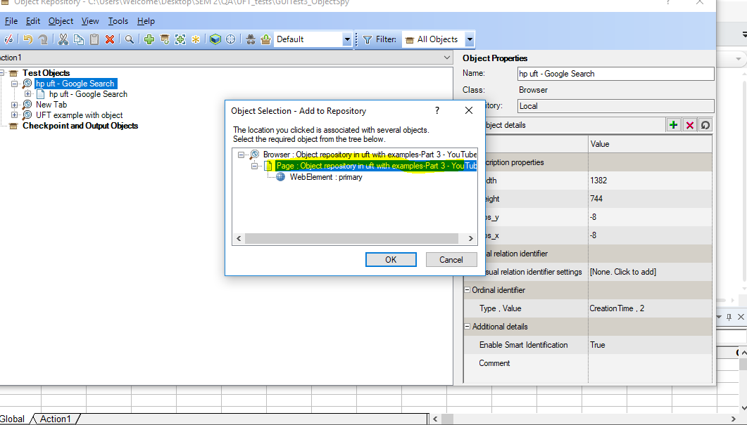

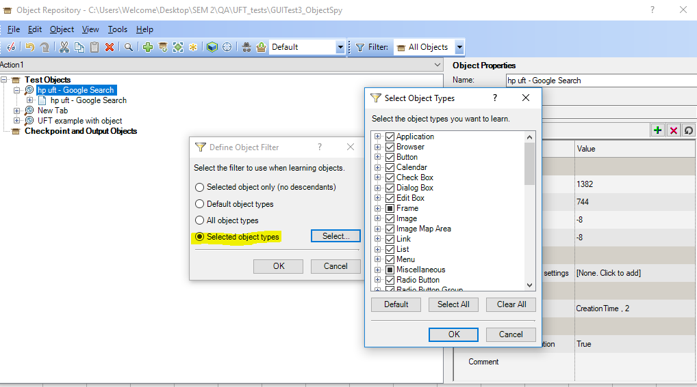

Note: If you select “All object types” then all objects will be added to the repository

To search if the object has changed its location use ‘highlight’ option:

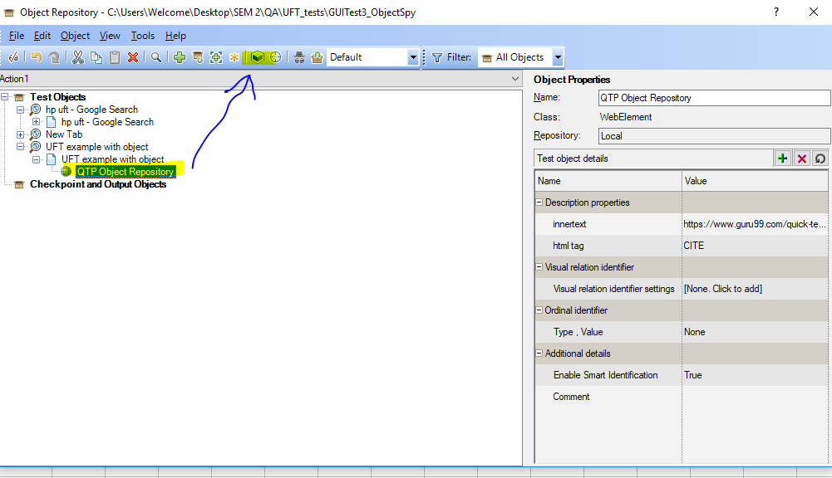

## Test 4: Opening file in vbscript

filePath = "C:\Users\Welcome\Desktop\SEM 2\QA\TestData.xlsx"  
  
**Set** xlApp = **CreateObject**("Excel.Application")  
xlApp.DisplayAlerts = **False**  
  
**Set** xlWb = xlApp.WorkBooks.Open(filePath)  
  
**Set** sheet1 = xlWb.Sheets(1)  
  
rowCount = sheet1.UsedRange.Rows.Count  
columnCount = sheet1.UsedRange.Columns.Count  
  
**MsgBox** sheet1.cells(2,1)  
  
**Set** xlApp= **nothing**  
**Set** xlWb = **nothing**  
**Set** sheet1 = **nothing**

# **Module 2**

## Checkpoints in UFT

Video link: <https://www.youtube.com/watch?v=e4CtPAdbL-M>

Web link: https://www.guru99.com/quick-test-professional-qtp-tutorial-13.html